

Grid Capacity Review
Scrutiny Committee Task & Finish Group
Guidance notes

This pack provides everything you’d need to replicate this process locally. The ‘Grid review introduction’ slides also give an introductory overview if you want to pitch it to colleagues.
Why bother?
As a reminder, this is a structured scrutiny activity – not a commissioned study of area-wide constraints. The purpose is to grow member/officer awareness of the issues; strengthen relationships with network operators; and secure a mandate to create a LAEP. You could also use it as a way of stirring interest in preparing for the RESP. It’s a simple and replicable approach to develop support and enthusiasm for energy planning – using grid constraints as a route in (rather than, say, renewables), and without a narrow net zero framing.
Things like the grid and energy planning, and the associated mass of acronyms and jargon, can make it difficult to get people engaged – because, ultimately, it’s dull and technical. This was an effective way to animate people’s interest in energy planning in a way that was accessible – and it’s easily replicable just by tweaking these documents. It might be particularly valuable as a means of getting support for developing a LAEP, as part of the early stages of engagement for a LAEP, or for sparking discussions on the RESP.
How?
- Read the final report as a primer to begin (2-3hrs).
Everything but section 8 is probably applicable to your area. Section 9 and the appendix overview recent reforms and relevant major national strategy, policy and plans.
- Pitch it to one of your scrutiny committee’s (or another suitable group of members).
You could tweak the APSE webinar slides for this. (1-2hrs).
- Tweak the materials to make them suitable to your area (3-4hrs).
You can mostly Ctrl+F ‘Dorset’ to do this. To find info on constraints in your local area, visit your DNO’s own website.
- Find a suitable set of local officers and stakeholders to participate (3-4hrs).
Your colleagues and your Net Zero Hub will likely help you reach external stakeholders if you’re not sure. I also googled lots and just sent emails inviting them – and most people got back and were enthusiastic. Your DNOs should have stakeholder engagement officers, or have generic stakeholder engagement email addresses you can find online. Planning colleagues or operational colleagues (like those involved in EV chargers) may also point you in their direction.
- Organise the meetings/sessions themselves (i.e. diaries, room bookings, catering) (2hrs)
The suggested structure is as noted. Following each session I shared the minutes and recordings of the session, and posted them on a shared Teams channel with the support materials. I also followed each session with a brief 30min chat with the Chair, to review the previous session and consider the next.
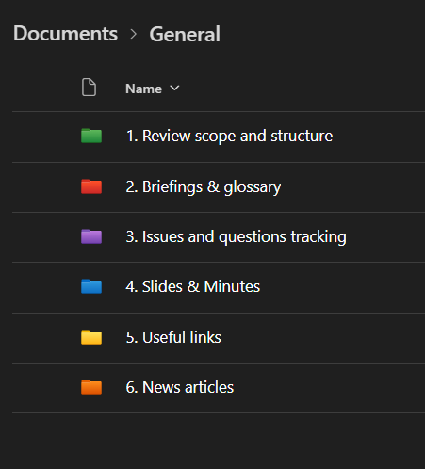
All the materials were stored on a shared Teams channel, structured as shown here.
Doing the above should be achievable in a day or two, and you don’t need any technical expertise or background knowledge to do this (I didn’t have it) – so you could easily delegate it too.
Combined with holding the sessions themselves, it should take no more than a week’s worth of your time.
What are the documents?
The documents are as follows:
1. Scope. This defines the scope, structure, stakeholders, and initial guiding questions, for agreement with your scrutiny committee (or whichever group of members you want to participate). It’s effectively a kind of terms of reference.
2. Background introductory briefing. This overviews key roles, terms, stakeholders and processes to introduce the issues from scratch. It recapitulates what’s in Session 1, but might be useful for the participants to have to refer back to.
3. Glossary. This is just a useful reference given the plethora of technical terms and acronyms. (Apologies this is an old version – if I can find the expanded later one I’ll share it).
4. Issues and questions tracker. This is to help give structure and focus to the discussions – as it’s really easy for the discussion to jump around in a way that doesn’t build properly. The ‘inquiry map’ visual (4b) was helpful in helping the participants and the Chair to navigate the multiple lines of questioning. Whilst what’s written largely reflects the schematic structure of types of questions raised in our own case, they’re probably similar to what you’ll experience – and you can easily supplement them if you think necessary. The tracker (4b) is essentially glorified (rationally reconstructed) minutes, but it helped participants reflect on and navigate the huge range of issues and strategically approach what they dig into – as well as helping the Chair to ensure focus.
5-8. Session agendas, slides and speaking notes. There’s an agenda for every session except the last. Each agenda also provides guidance on questions they could ask (to help keep focus). Slides were only produced for Sessions 1 and 2 – they are attached along with the corresponding speaking notes (which are also embedded in the slidepacks). I’ve removed some of the EV charger slides as they’re particular for us, but you could slot what you like in there or remove it.
9. Final report and cover report. Most bits of the final report are easily liftable, and you can Ctrl+F ‘Dorset’ to find the bits you need to switch out. The cover report you’ll likely have to tweak a bit more to make it suitable for whatever your internal governance is.
10. Member webinar. The summarised the findings and outputs to all councillors.
11. LAEP introduction. This is the invitation to participate in the LAEP once the consultants were in place, and is taking place several months after all the earlier bits.

